**How to Build the Dementia Friendly Music Player**

10 May 2018, <http://dqmusicbox.org>, Ross Porter [rosswesleyporter@gmail.com](mailto:rosswesleyporter@gmail.com)

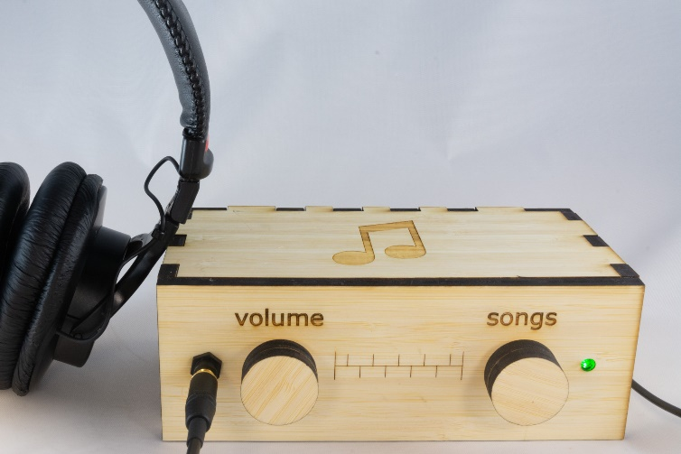  
  
My Dad could not operate normal music players. But he could operate this music player because it operates like a familiar two-knob radio. My son & I were inspired to design this by the documentary [Alive Inside](http://www.aliveinside.us/#land) which shows the profound joy felt by some people with dementia when listening to their favorite music.

It’s easier than you think to make one. Everything I did (e.g. software, wood case design) is open source. This document contains all the information you need. You can order the parts online. Good project for kids. A 13 year old can do this with minimal assistance. Younger kids with more assistance.



|  |  |
| --- | --- |
| **Parts cost** | ~$90 + tax + shipping |
| **Music cost** | Minimal as you should use the recipient’s existing music collection |
| **Build time** | About two hours, once you have the parts & music |
| **Parts source** | All parts can be mail ordered, links below |
| **Soldering?** | No |
| **Woodworking?** | No |
| **Laser cutter needed?** | No, you can mail order the pre-cut pieces for the wood case |
| **With a friend?** | Good idea, especially if your friend has the basic tools required |
| **Beverage?** | I recommend a hoppy IPA while you are assembling |

|  |  |
| --- | --- |
|  |  |

# Preview of the steps

|  |  |  |
| --- | --- | --- |
| **1) Order parts** | **2) Assemble recipient’s favorite music**  Complete Beethoven Edition, Vol. 1: Symphonies | **3) Copy software to micro SD card**  http://ecx.images-amazon.com/images/I/71sgCaQGpKL._SL1500_.jpg |
| **4) Receive the parts** | **5) Glue** | **6) Wire the knobs** |
| **7) Wire everything else** | **8) Enjoy** |  |

# No warranty

USE THESE DQMUSICBOX PLANS AND SYSTEM AT YOUR OWN RISK. THE DQMUSICBOX PLANS ARE PROVIDED AS IS WITHOUT WARRANTY OF ANY KIND EITHER EXPRESSED OR IMPLIED, INCLUDING, BUT NOT LIMITED TO, THE IMPLIED WARRANTIES OF MERCHANTABILITY AND FITNESS FOR A PARTICULAR PURPOSE. THE ENTIRE RISK AS TO THE QUALITY AND PERFORMANCE OF THE PLANS AND SYSTEM IS WITH YOU. SHOULD THE PLANS OR SYSTEM PROVE DEFECTIVE, YOU ASSUME THE COST OF ALL NECESSARY SERVICING, REPAIR OR CORRECTION. IN NO EVENT WILL ANY PARTY BE LIABLE TO YOU FOR DAMAGES, INCLUDING ANY GENERAL, SPECIAL, INCIDENTAL OR CONSEQUENTIAL DAMAGES ARISING OUT OF THE USE OR INABILITY TO USE THE PLANS OR SYSTEM.

# Acknowledgements

People were very generous with their time, and I really enjoyed the experience. This is certainly an incomplete list: Alex & Mike & others at [Ada’s](http://blog.seattletechnicalbooks.com/), the super smart staff at [Metrix](http://www.metrixcreatespace.com/), neighbor Randy, [Stephen Christopher Phillips](http://scphillips.com/), [Bob Rathbone](http://www.bobrathbone.com/), [Stephen Rusk](http://www.stephenrusk.com/), [Graham Hill](http://www.ted.com/speakers/graham_hill), support at [Ponoko](https://www.ponoko.com/), and my son.

# What DQMusicBox does

## For the person with dementia

|  |  |
| --- | --- |
| **Name** | **Description & implementation** |
| Start song | Turning either of the knobs will start music playing. |
| Change song | Turn the songs knob. |
| Change volume | Turn the volume knob. |
| Pause | Tap the volume knob. Note that this also happens automatically – music pauses if there are no knob events in one hour. |

## For you

|  |  |
| --- | --- |
| **Name** | **Description & implementation** |
| Shut down | Pull the power plug or long hold (15-30 seconds) on the volume knob. |
| Reboot | Pull the power plug and re-insert or long hold (15-30 seconds) on the songs knob. |
| Add/remove music | By adding/removing files on the USB memory stick. |

# Order the parts

## The parts

Here are the parts that you will be using:

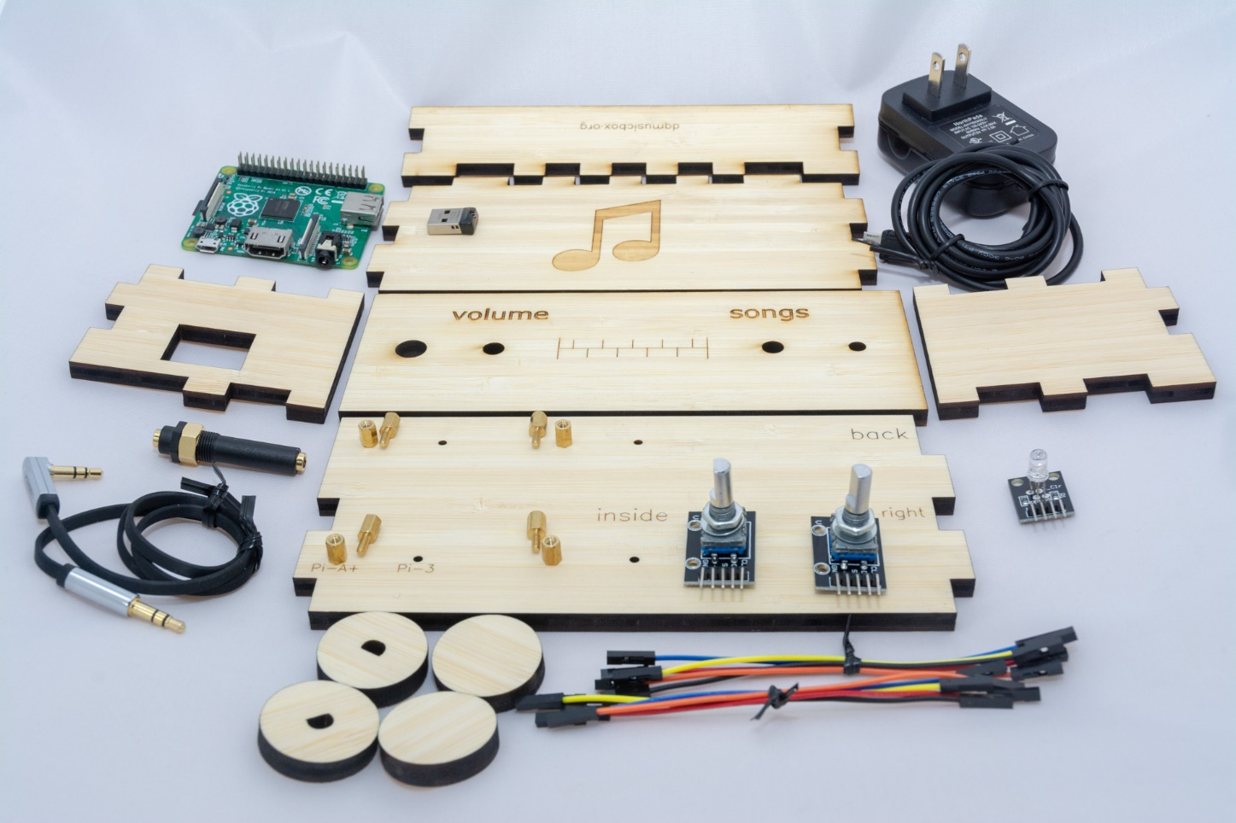

## Create a Ponoko account (optional but convenient)

Ponoko is a company that laser cuts wood and sends you the precisely cut pieces. You don’t need to use Ponoko – you are welcome to take [my case design files](https://www.ponoko.com/design-your-own/products/case-for-dementia-friendly-music-player-bamboo-14808) to your local maker space and use the laser cutter there. Or buy yourself a laser cutter (if you do, will you be my friend?). In other words, Ponoko is convenient but not necessary. I have no affiliation with them, other than being a happy customer. To create a Ponoko account:

1. Go to <https://www.ponoko.com/>
2. Choose “Get Making”

## Order from Ponoko

1. Go to <https://www.ponoko.com/design-your-own/products/case-for-dementia-friendly-music-player-bamboo-14808>
2. Click on “Add to Personal Factory”
3. Login
4. Check to accept the license, click “Add”
5. The result should be:  
   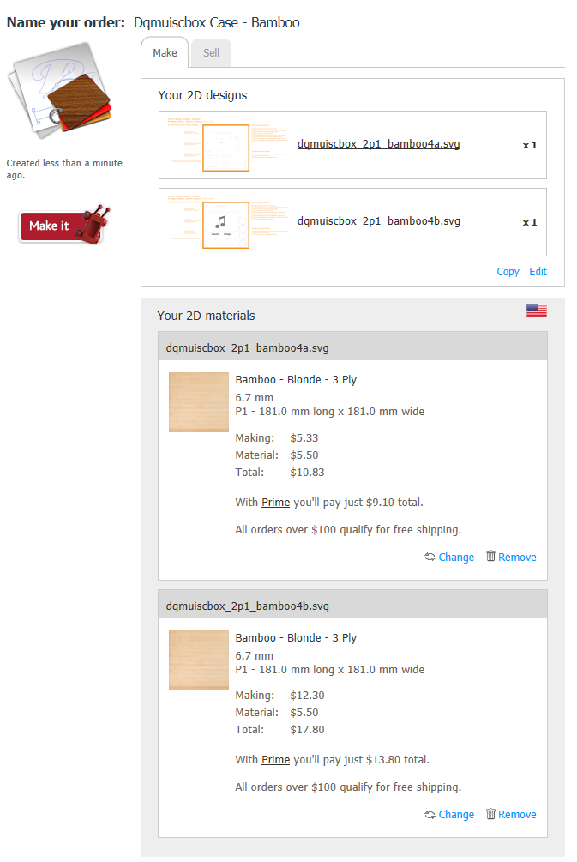
6. Click “Make it”

## Order the remaining parts - US

|  |  |  |  |
| --- | --- | --- | --- |
| **Item** | **Supplier** | **Cost (2018)** | **Notes & Alternatives** |
| DQMusicBox bamboo case | Ponoko | $28.63 | See instructions above. |
| [Raspberry Pi A+ single board computer](http://www.newark.com/raspberry-pi/raspbrry-moda-512m/silicon-manufacturer-broadcom/dp/81Y5333) | MCM/Newark | $20.00 | Or buy from [Allied](https://www.alliedelec.com/raspberry-pi-raspberry-pi-a-/70428330/?src=raspberrypi) or [Amazon](https://www.amazon.com/Raspberry-Pi-512MB-2016-Model/dp/B01MA1CQT7/ref=sr_1_4?ie=UTF8&qid=1519712159&sr=8-4&keywords=raspberry+pi+Model+A%2B). Or use a [Raspberry Pi 3 B+](https://www.amazon.com/Element14-Pi-Modell-Raspberry-Motherboard/dp/B07BDR5PDW/ref=sr_1_5?ie=UTF8&qid=1523165538&sr=8-5&keywords=raspberry+pi+3+b%2B) or 3B or 2B. |
| [Power supply](http://www.mcmelectronics.com/product/28-19338) | MCM/Newark | $5.99 | This is the US model. Any micro USB 2A or better supply will do. |
| [Female-female jumper wires](http://www.newark.com/adafruit/266/female-to-female-jumper-wires/dp/42X1200) | MCM/Newark | $3.56 | Or buy Amazon [B01L5ULRUA](https://www.amazon.com/GenBasic-Female-Solderless-Breadboard-Prototyping/dp/B01L5ULRUA/ref=sr_1_3?s=electronics&ie=UTF8&qid=1524365861&sr=1-3&keywords=female+female+jumper+wires) |
| [Panel mount 3.5mm headphone jack](http://www.newark.com/mcm/27-5937/3-5mm-inline-stereo-mount-female/dp/40T6284) | MCM/Newark | $2.69 | Or buy Amazon [B004JX64FE](https://www.amazon.com/3-5mm-Stereo-Feed-Thru-Panel-Mount/dp/B004JX64FE/ref=sr_1_1?s=electronics&ie=UTF8&qid=1508035643&sr=1-1&keywords=B004JX64FE) |
| [M2.5 standoffs (screws)](http://www.newark.com/raf-electronic-hardware/m2102-2545-al/spacer-standoff-hex-aluminium/dp/27T7975?st=M2.5%20standoff) | MCM/Newark | $3.14 | Or by Amazon [B06XXV8RTR](https://www.amazon.com/eBoot-Pieces-Female-Standoff-Assortment/dp/B06XXV8RTR/ref=sr_1_1?s=electronics&ie=UTF8&qid=1508035656&sr=8-1&keywords=B06XXV8RTR) |
| [Micro SD card 16GB](https://www.amazon.com/SanDisk-MicroSDHC-SDSDQM-B35A-Without-Adapter/dp/B004ZIENBA/ref=sr_1_5?s=pc&ie=UTF8&qid=1524539733&sr=1-5&keywords=micro+sd+card+8GB) | Amazon | $6.95 | Any brand name micro SD card that is 8GB or larger will do. |
| [USB thumb drive 16GB](https://www.amazon.com/dp/B005FYNSZA/ref=twister_B00JO6RO8C?_encoding=UTF8&th=1) | Amazon | $6.97 | While nearly any USB thumb drive will work, I recommend one that is physically tiny so it doesn't protrude much from the case. |
| [Audio cable](https://www.amazon.com/gp/product/B00LM0U8I6/ref=oh_aui_detailpage_o00_s00?ie=UTF8&psc=1) | Amazon | $5.29 | Or find a short audio cable with a right angle bend. |
| [KY-016 indicator LED (note shipping time)](https://www.ebay.com/itm/5pcs-KY-016-RGB-3-Color-Full-Color-LED-Module-for-Arduino/400985215745?epid=1148542974&hash=item5d5c94d301:g:2RUAAOSw3EVaYbqU) | eBay | $1.62 | The linked seller ships from China, takes 2-3 weeks, but the case takes a while to arrive as well. Or order as one piece of this kit - Amazon [B013UL6LFS](https://www.amazon.com/SainSmart-Arduino-Mega2560-Mega328-Raspberry/dp/B013UL6LFS/ref=sr_1_2?s=electronics&ie=UTF8&qid=1519626123&sr=1-2&keywords=KY-016), which will arrive in a few days. |
| [KY-040 rotary encoders (knobs)](https://www.ebay.com/itm/2pcs-KY-040-Rotary-Encoder-Module-for-Arduino-AVR-PIC-NEW-NA/192515681948?epid=755667868&hash=item2cd2d42e9c:g:Ct0AAOSwIrpaoF6Q) | eBay | $5.39 | The [linked seller](https://www.ebay.com/itm/2pcs-KY-040-Rotary-Encoder-Module-for-Arduino-AVR-PIC-NEW-NA/192515681948?epid=755667868&hash=item2cd2d42e9c:g:Ct0AAOSwIrpaoF6Q) ships from the US. If not available from that seller, search eBay for KY-040, look carefully at the product photo -- you need encoders with screw threads. Amazon sometimes has KY-040 as well, though they generally ship from China. |
| **TOTAL** |  | **$90.23** | Prices will vary. Does not include tax, shipping. |

## Ordering parts – UK

I have not used the UK suppliers below, but the parts below are likely to work. Alternatively, you can order from the US, using the list above.

|  |  |  |  |
| --- | --- | --- | --- |
| **Item** | **Supplier** | **Cost (2018)** | **Notes & Alternatives** |
| DQMusicBox bamboo case | Ponoko US | £ 21.93 | See instructions above. Alas, £24 in shipping from US. But it is the easiest method. Perhaps find other people that want to build one, and split the shipping charges. As per above, you are also welcome to download the case plans and find a local laser cutter. |
| [Raspberry Pi A+ single board computer](https://www.amazon.co.uk/Raspberry-Pi-Model-Plus-Motherboard/dp/B00Q8MM4PI/ref=sr_1_7?ie=UTF8&qid=1502072940&sr=8-7&keywords=raspberry+pi+A%2B) | Amazon UK | £ 20.88 | Made in the UK! |
| [Power supply](https://www.amazon.co.uk/dp/B01MFFSPHE/ref=sspa_dk_detail_2?psc=1&pd_rd_i=B01MFFSPHE&pd_rd_wg=xt0QU&pd_rd_r=YN2XYKHXDM1BFGP5CZ95&pd_rd_w=caHZA) | Amazon UK | £ 6.99 | Or any micro USB 2A or better supply will do. |
| [Female-female jumper wires](https://www.amazon.co.uk/Elegoo-120pcs-Multicolored-Breadboard-arduino/dp/B01EV70C78/ref=sr_1_1?s=industrial&rps=1&ie=UTF8&qid=1524543943&sr=1-1&keywords=female+female+jumper+wires&refinements=p_76%3A419158031&dpID=61TQP733AwL&preST=_SX342_QL70_&dpSrc=srch) | Amazon UK | £ 5.95 |  |
| [micro SD card 16GB](https://www.amazon.co.uk/SanDisk-SDSDQB-016G-B35-Class-MicroSD-Adapter/dp/B002Q5H3JI/ref=sr_1_3?s=computers&ie=UTF8&qid=1508036268&sr=1-3&keywords=8GB+micro+SD) | Amazon UK | £ 6.50 | Any brand name micro SD card that is 8GB or larger will do. |
| [USB thumb drive 16GB](https://www.amazon.co.uk/Cruzer-Fit-Flash-Drive-SDCZ33-016G-B35/dp/B005FYNSZA/ref=sr_1_1?s=computers&ie=UTF8&qid=1502073207&sr=1-1&keywords=sandisk%2BUSB%2B8GB%2Blow%2Bprofile&th=1) | Amazon UK | £ 7.49 | While nearly any USB thumb drive will work, I recommend one that is physically tiny (like this one) so it doesn't protrude much from the case. |
| [KY-040 rotary encoder (knobs)](https://www.amazon.co.uk/Cylewet-Encoder-15%C3%9716-5-Arduino-CLW1062/dp/B06XT58ZW9/ref=sr_1_1?s=computers&ie=UTF8&qid=1524544229&sr=1-1&keywords=KY-040&dpID=41CHiNuM8nL&preST=_SY300_QL70_&dpSrc=srch) | Amazon UK | £ 8.69 | Or search for KY-040 at your favorite supplier. Look carefully at the product photo -- you need encoders with screw threads. |
| [KY-016 indicator LED](https://www.amazon.co.uk/TOOGOO-KY-016-Color-Module-Arduino/dp/B075LDC5XF/ref=sr_1_5?ie=UTF8&qid=1524544436&sr=8-5&keywords=KY-016) | Amazon UK | £ 1.37 | Ships from China, so supposedly 7-12 business days. But the case may take a while to arrive as well. To get this part faster order Amazon ASIN [B01DIU7TSO](https://www.amazon.co.uk/SainSmart-Arduino-Mega2560-Mega328-Raspberry/dp/B01DIU7TSO/ref=sr_1_1?ie=UTF8&qid=1508035731&sr=8-1&keywords=B01DIU7TSO), but more expensive and ships with a bunch of fun parts that you probably don’t need. Or search for more KY-016 sources. |
| [Audio cable](https://www.amazon.co.uk/UGREEN-Headphones-Stereos-Smartphones-Speakers/dp/B00LM0U8I6/ref=sr_1_1?ie=UTF8&qid=1502079597&sr=8-1&keywords=ugreen+stereo+audio+cable+3.5mm+0.5m) | Amazon UK | £ 5.69 | Or search "audio cable right angle". |
| [M2.5 standoffs (screws)](https://www.amazon.co.uk/eBoot-Pieces-Female-Standoff-Assortment/dp/B06XXV8RTR/ref=sr_1_1?ie=UTF8&qid=1502076810&sr=8-1-spons&keywords=M2.5+standoff&psc=1) | Amazon UK | £ 9.99 | Use the 6mm+6mm standoffs i.e. the smallest ones. |
| [Philmore 3.5mm Stereo Panel Mount Female Audio Feed-Thru Jack](http://www.ebay.co.uk/itm/Philmore-3-5mm-Stereo-Panel-Mount-Female-Audio-Feed-Thru-Jack-/271403933364?hash=item3f30ef5eb4:g:CmwAAOSwa9NZyX7u) | eBay UK | £ 6.73 | On eBay this is listed as a 2.5mm jack, but I’m pretty sure it’s a 3.5mm jack. The part will ship from the US and this seems the cheapest way to buy it in the UK. |
| **TOTAL** |  | **£ 102.21** | Prices will vary. Does not include tax, shipping. |

## About headphones

|  |  |  |
| --- | --- | --- |
| **Item** | **Cost $US, May 2017** | **Notes and alternatives** |
| The recipient’s existing headphone | $0.00 | The best headphones are the headphones that the recipient is already used to. |
| [Panasonic RP-HT21](https://www.amazon.com/gp/product/B00004T8R2/ref=oh_aui_search_detailpage?ie=UTF8&psc=1) | $6.25 | OK sound. Long cord. |
| [AmazonBasics On-Ear Headphones](https://www.amazon.com/gp/product/B00NBEWB4U/ref=oh_aui_search_detailpage?ie=UTF8&psc=1) | $14.99 | Good sound. Cord is a bit short. |
| [Sony MDR7506](https://www.amazon.com/dp/B000AJIF4E/?tag=thewire06-20&linkCode=xm2&ascsubtag=AgEAAAAAAAAAAAQbAAAAABWh_YcAAAAAV0Crgw) | $79.99 | Amazing sound. My Dad loved the sound. But he found the headphones to be a bit frustrating – they tend to fold themselves up. |

## Tools & supplies

You probably have some of these tools & supplies. If you don’t, you have a spouse or child or friend that does. This project is exactly the sort of thing that a friend would be happy to help you with.

|  |  |
| --- | --- |
| **Link to order item** | **Notes & alternatives** |
| Elmer’s wood glue | Any wood glue will do |
| 3/16th wrench or nut driver | Or needle-nosed pliers. Or really strong fingers |
| SD card reader/writer | Your computer may have an SD card reader/writer. If not, you probably have a friend that does. Or order a [USB SD-card reader](https://www.amazon.com/gp/product/B00OJ5WBUE/ref=oh_aui_search_detailpage?ie=UTF8&psc=1) for your computer. |
| Painter’s tape | Any tape that comes off easily will do. Painter’s tape is great. Regular masking tape is probably fine too. I haven’t tried Scotch tape. |
| Raspberry Pi 3 (optional) | This is in addition to the Pi that goes in the player. This is a completely optional step. If you are nerd like me, or you have nerdly friend, see details in the appendix 1. |

# Assemble the personalized collection of music

## Choosing the music – go for familiar favorites

This is the most important step. The personalized (familiar) music is the fundamental magic. You don’t need much music, perhaps 6-10 albums. But only familiar favorites. In my case, my Mom mailed me my Dad’s favorite CDs. It will take two weeks for the parts above to arrive, so you have time to do this well. Though it is easy to change the set of music later.

## Put the music on the USB memory stick

Organize the digitized music into folders on the USB memory stick, one folder per album. MP3, iTunes, and FLAC files are supported i.e. files with extensions .mp3, .m4a, .flac. In the end, you should have a set of folders that looks something like this:

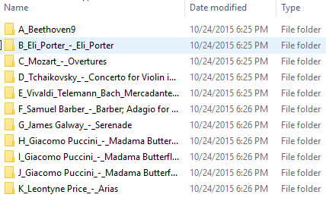

# Prepare the micro-SD memory card

I prepared a disk image for you. It has all the required software. Your job is to download this disk image and then write it to the micro-SD card. The steps:

1. Install [Etcher](https://etcher.io/) on your PC or Mac or Linux computer. [Win32 Disk Imager](http://sourceforge.net/projects/win32diskimager/) also works.
2. Download the [DQMusicBox disk image](https://drive.google.com/file/d/1KfX1c5kkElc7vPr1dqlflSw7jf-w31Af/view). 935MB.  
   
3. Confirm download – “Download anyway”  
   
4. Put the micro-SD memory card into the SD card adapter that it came with i.e. put the tiny card into the larger card.
5. Put the SD card adapter into the SD reader/writer in your computer.
6. Start Etcher, instruct it to write the image file to the SD card:  
   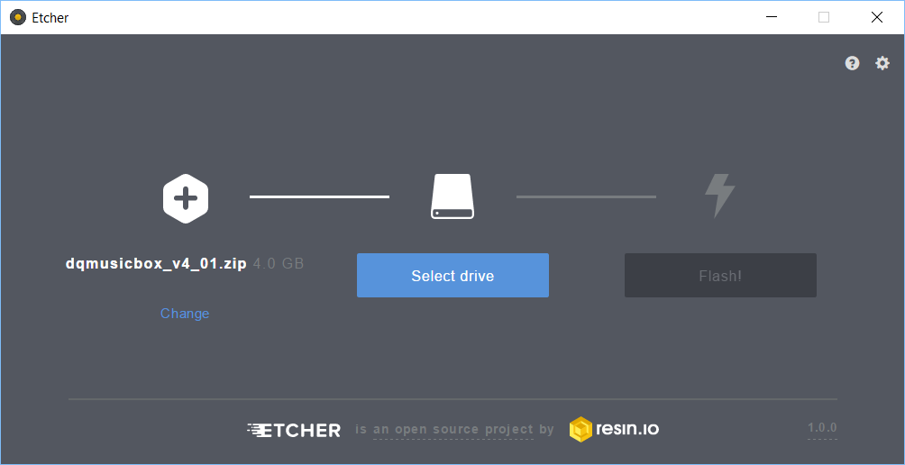
7. Wait for the writing to complete, ~10 minutes. This would be a good time to make a sandwich.
8. If you are a nerd or your friend is a nerd, see the optional step in Appendix 1.

# Make it

Below is finished product that you will create in the steps further below.

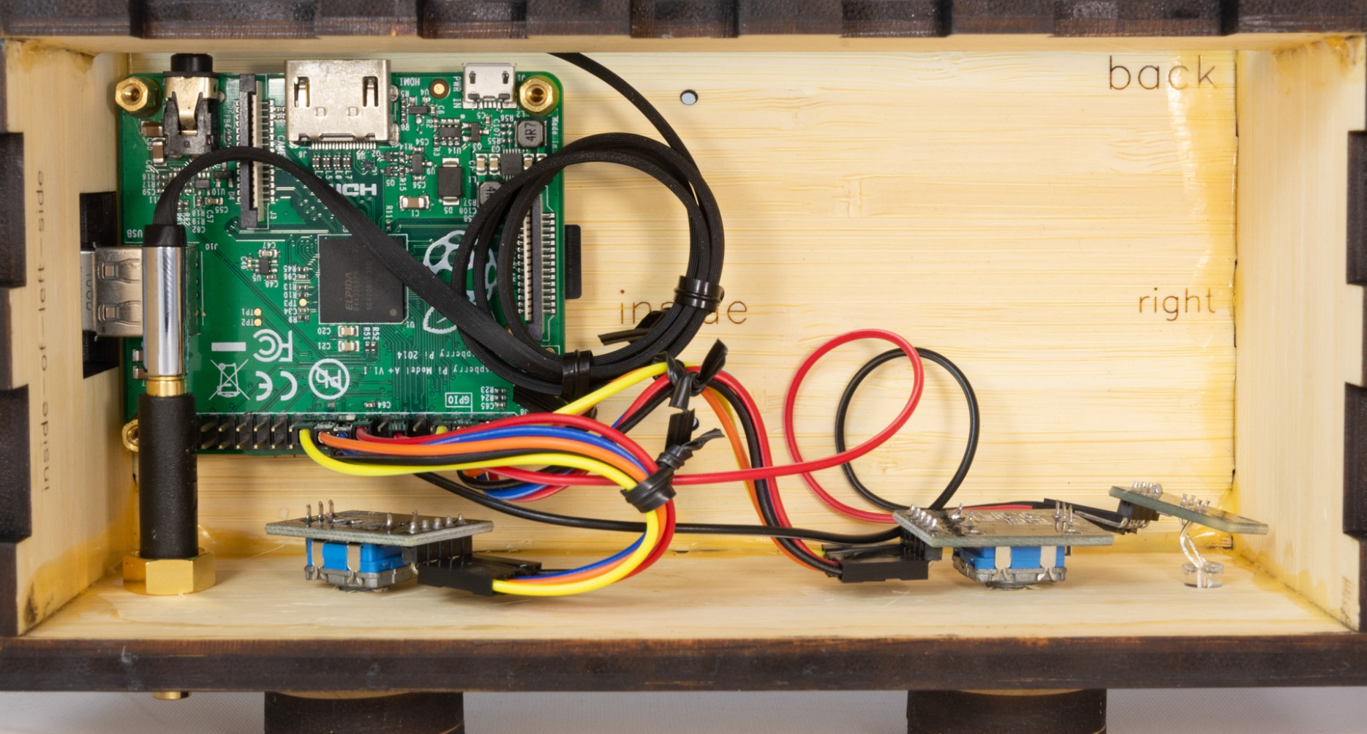

## Screw in the standoffs

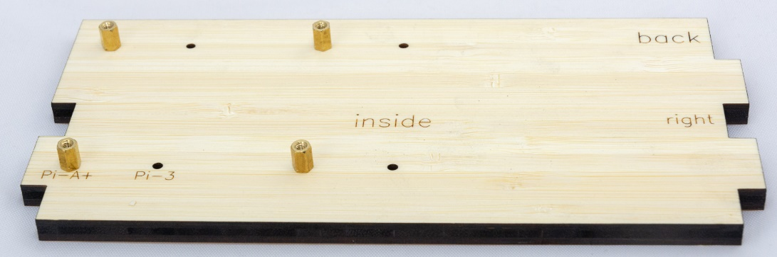

## Screw in knobs (rotary encoders)

Screw in the rotary encoders (knobs). Not pictured, but if you like you can also attach the LED and the audio jack now (some people prefer this method).

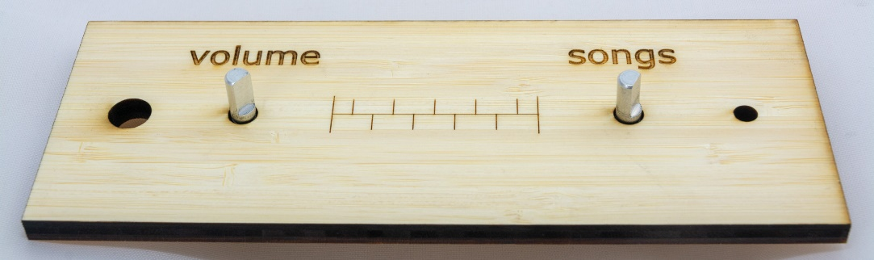

## Add glue

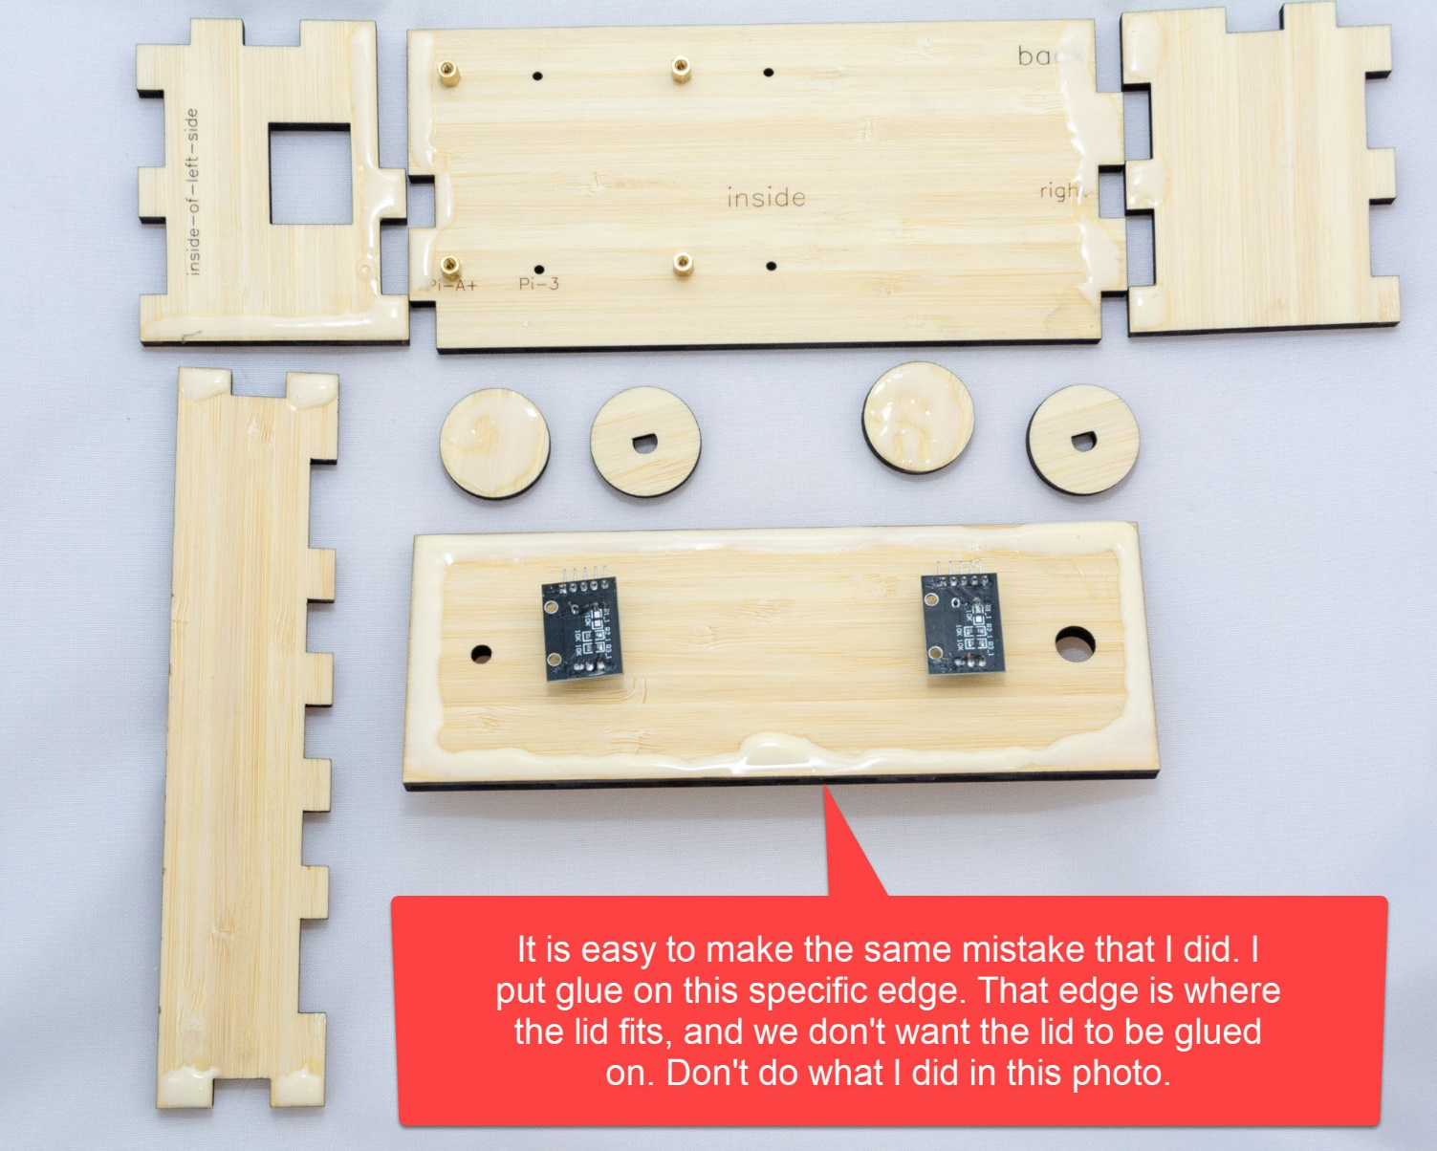

## Add Raspberry Pi

To attach the Raspberry Pi, use four more standoffs.

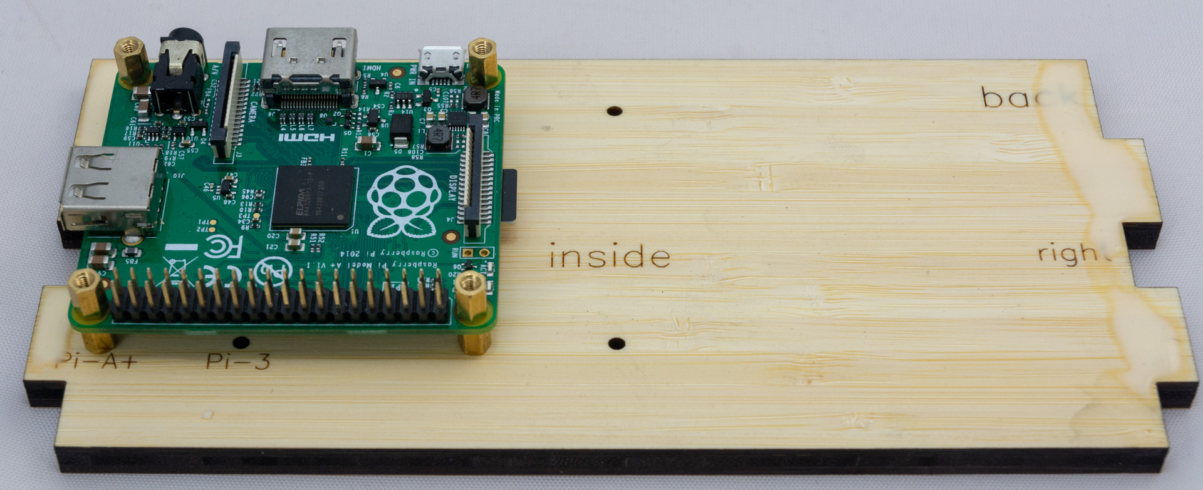

## Glue all but the lid

Glue all but the lid together. To hold it together while drying, use painter’s tape. After you have taped it, make sure that the lid fits. **But don’t glue the lid on**. I suggest checking the lid fit again after 30 minutes. The lid should be fit snugly, but come off with a bit of effort. **Again, don’t glue the lid on.**

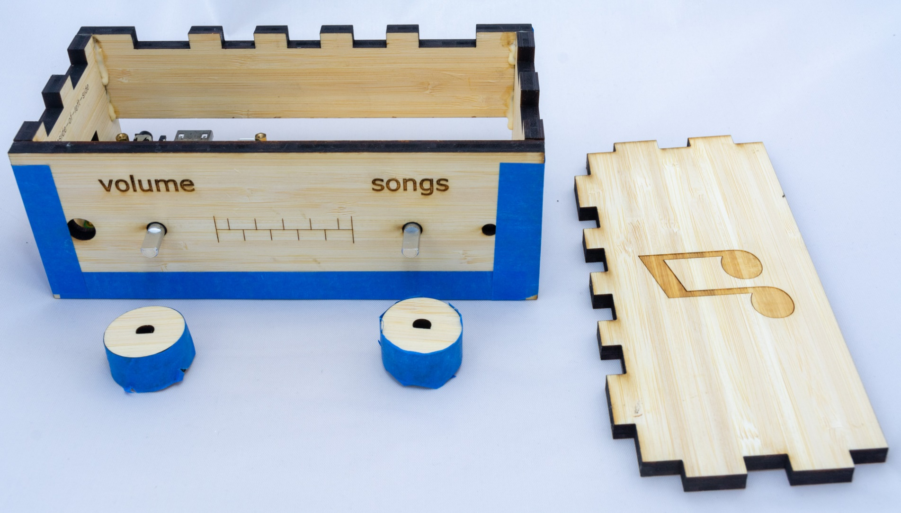

## Let the glue dry overnight OR carefully continue building, attach wood knobs

Now you have a choice:

* Let the glue dry overnight, then continue. This is what I do. OR
* Proceed without letting the glue dry i.e. build the whole thing in one sitting. Just be careful to not get glue on other bits.

In either case, start by attaching the wood knobs. Don’t worry if the knobs don’t fit snugly on the metal shafts. You can always add a bit of glue later.

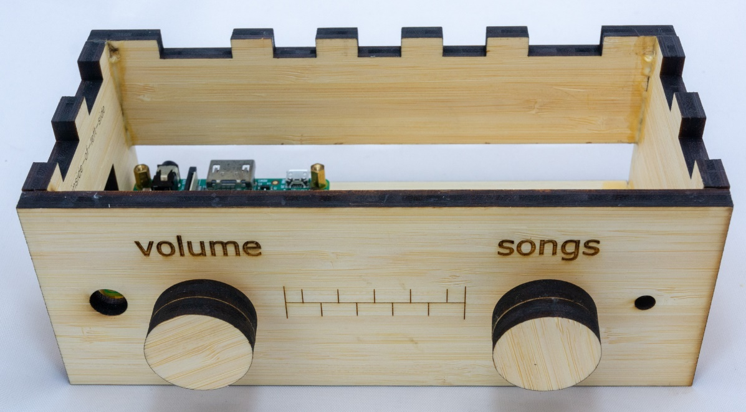

## Wire up the knobs and the LED

Attach wires from the knobs and the LED to the Raspberry Pi as per the diagram and photos below. No soldering required – just press the wires into place. **This is where most build errors happen, so please carefully check your work.**



For the knobs & LED, the result should be what you see below. The LED will not go all the way through the hole. Which is good, as the LED is rather bright. Use a bit of glue to hold it in place if needed.

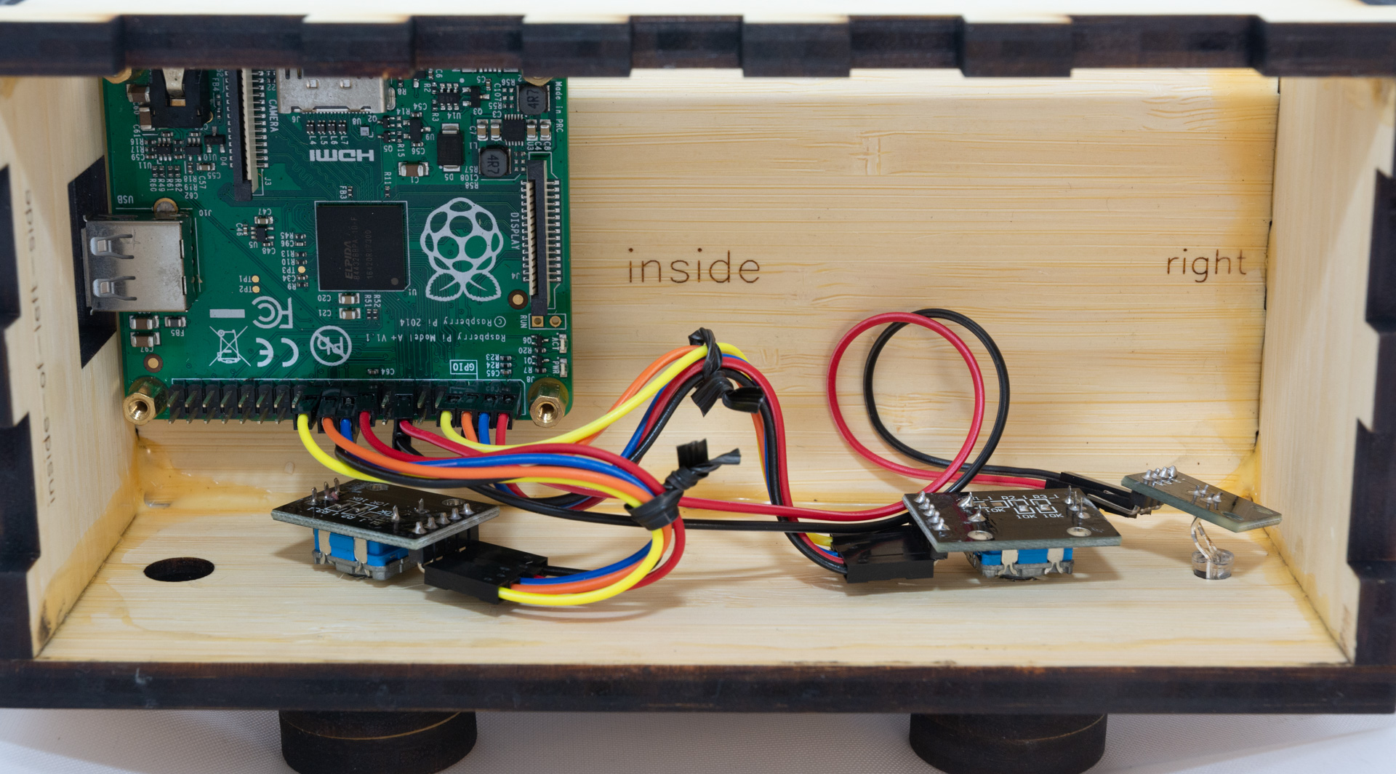

## Screw in the headphone socket

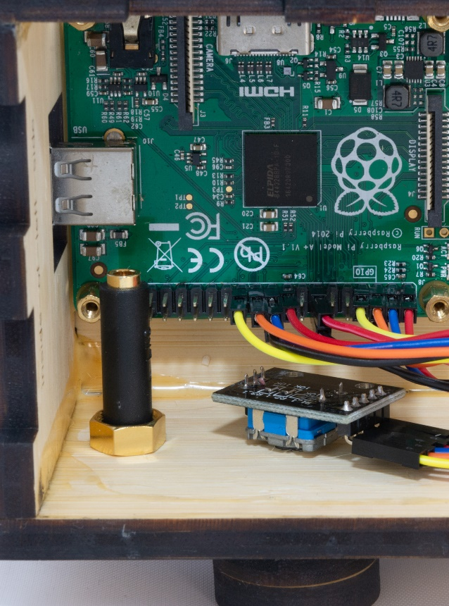

## Connect the audio cable

Connect the audio cable from the headphone socket that you just installed to the headphone socket on the back of the Raspberry Pi, see the silver bits below:

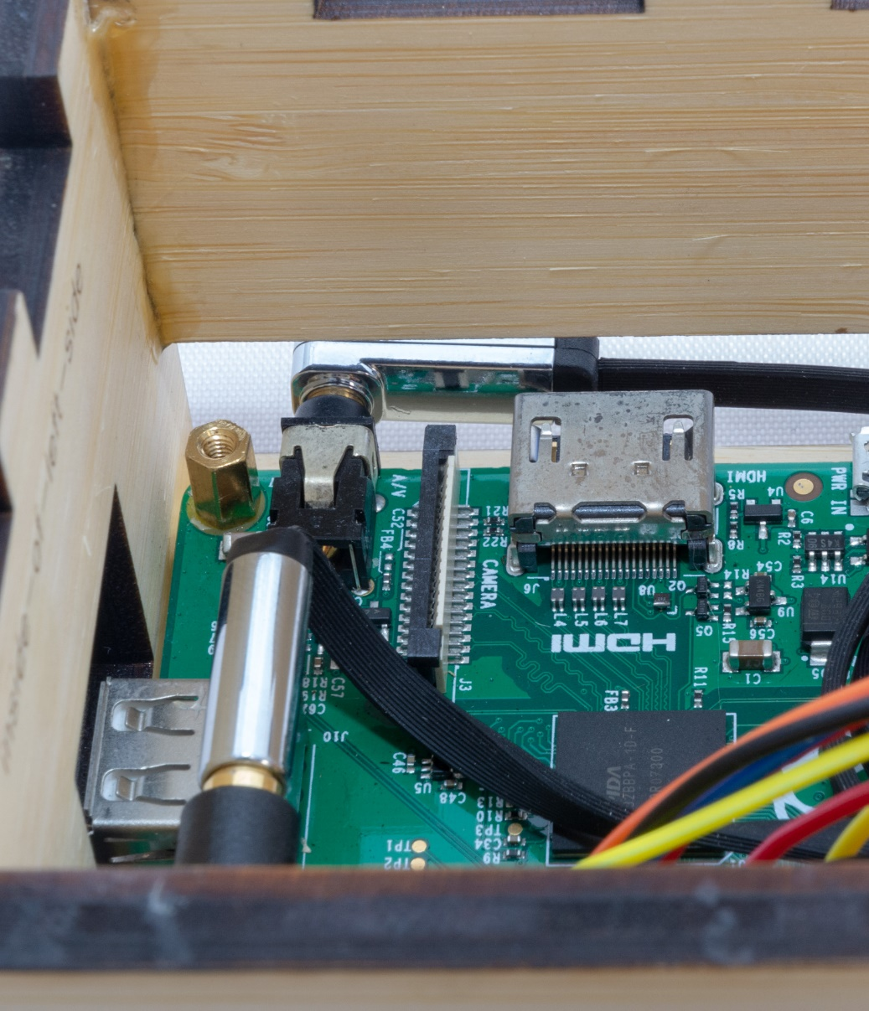

## Insert the micro SD card

The micro SD card goes in a socket on the underside of the Raspberry Pi. Once inserted, only a small portion of the micro SD card is visible. See the photo below showing the micro SD card just above the letters “de”.

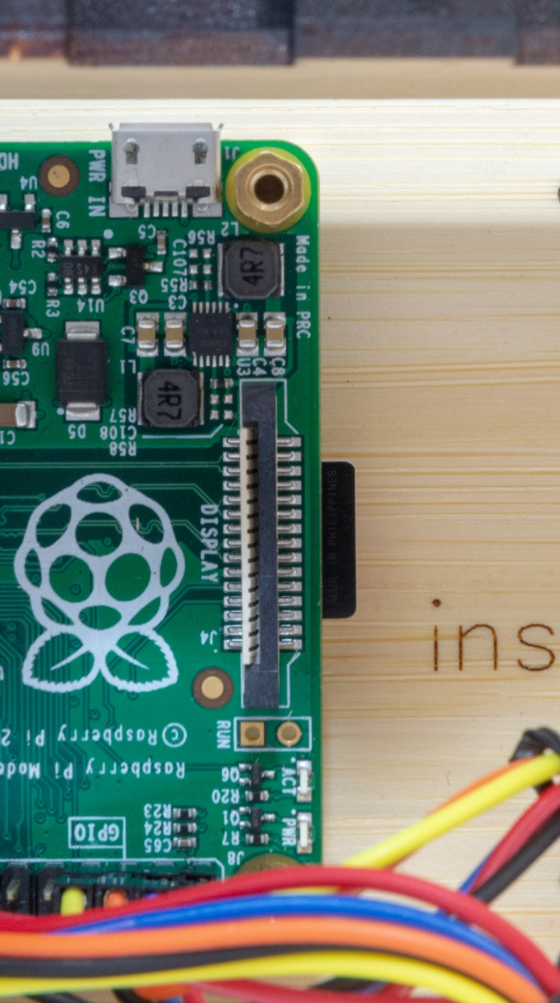

## Insert the USB memory stick (the music)

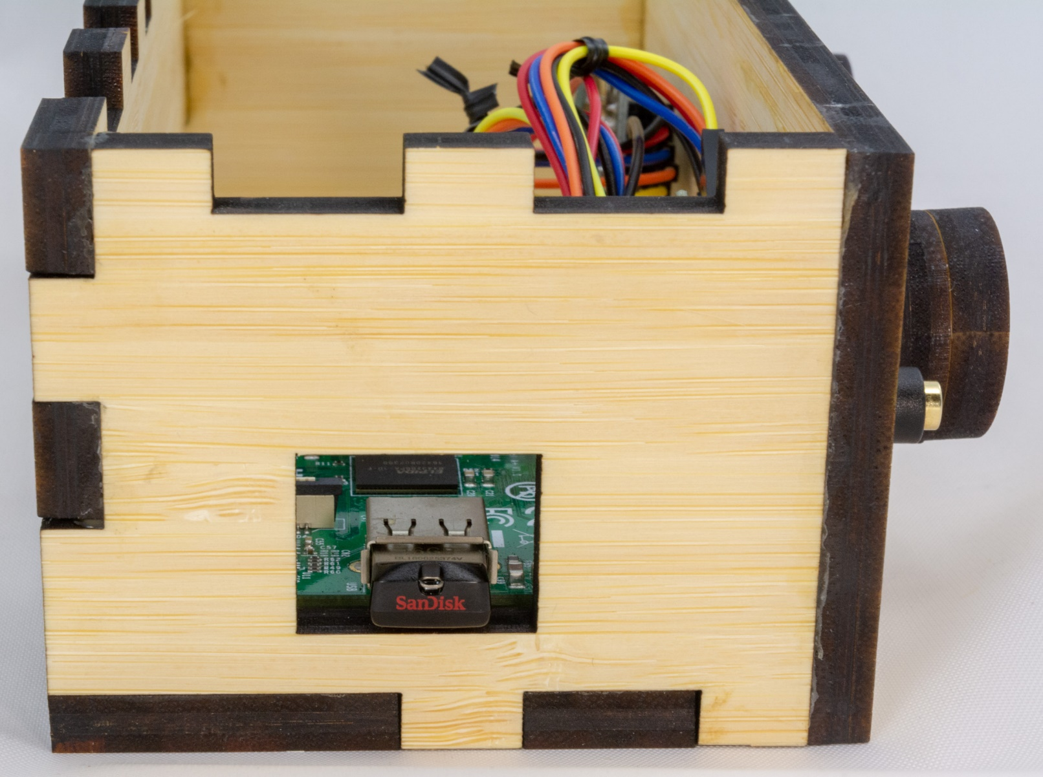

## Put the lid on

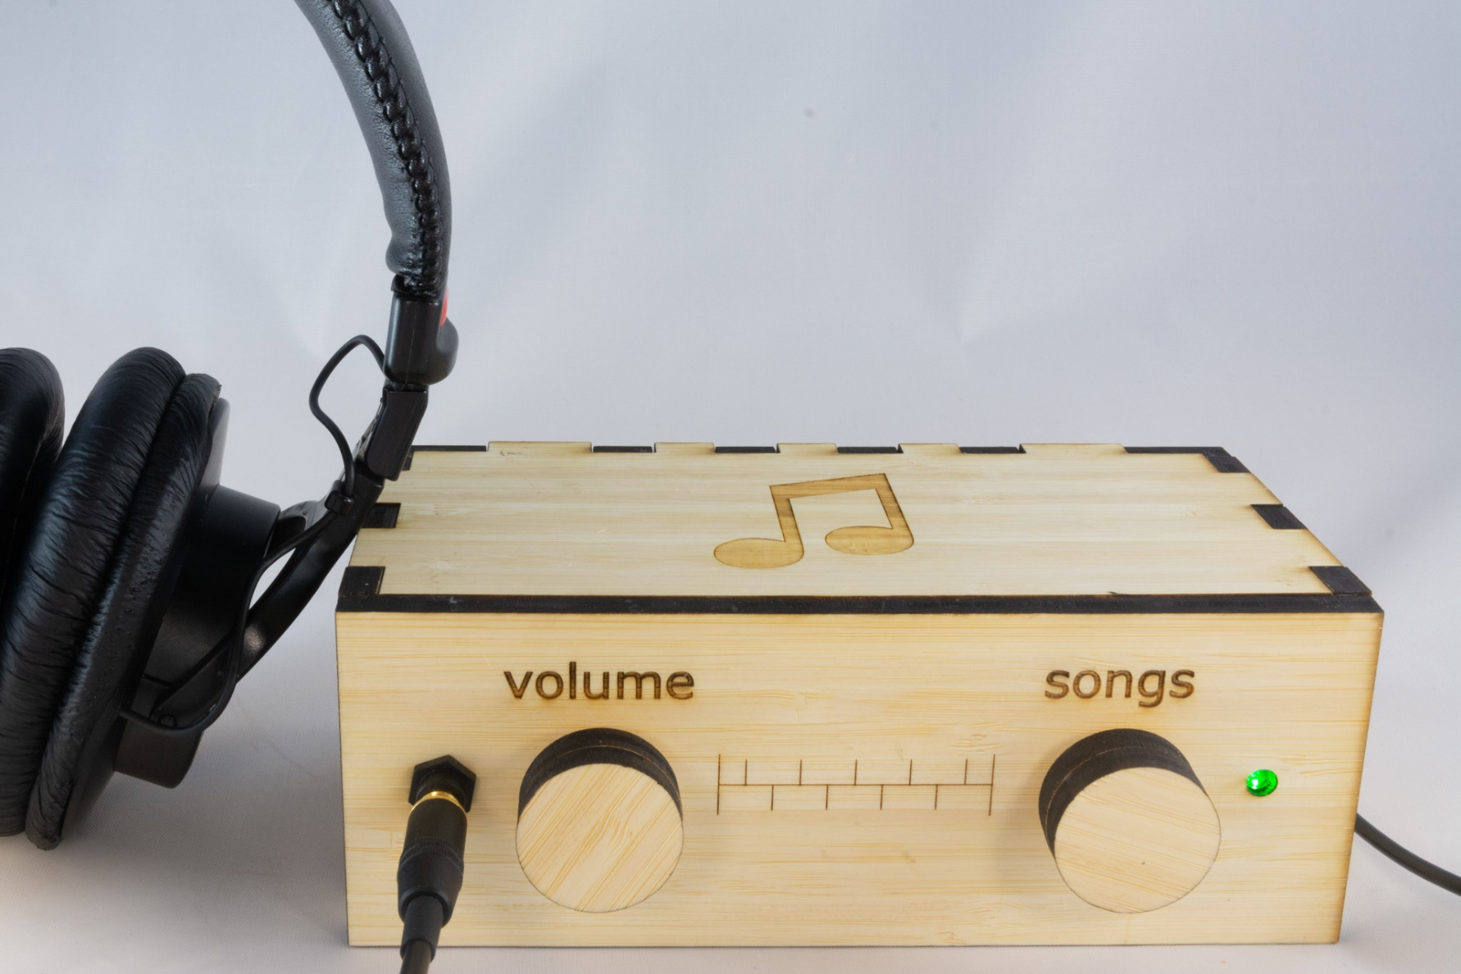

## Test it

Now that you have assembled everything, it is time to test.

|  |  |
| --- | --- |
| **Test** | **Description & Expectation** |
| Light 20sec after power on | The indicator LED turns on when DQMusicBox is ready to play music, which is generally about 15 seconds after power on. |
| Start song | Turning either of the knobs will start music playing. |
| Change song | Turn the songs knob. If you go forward and backward through the song list as expected, then all is well. |
| Change volume | Turn the volume knob. If the volume goes up and down as expected, then all is well. |
| Pause | Tap the volume knob, song should pause. Tap the songs knob, this should also pause the song. |
| Unpause | Tap a knob |

## If one or both knows do the opposite of what you expect

Once assembled, you may find your knobs doing the opposite of what you expect e.g. a clockwise turn decreases the volume. This is because there are two kinds of rotary encoders out there. Happy, the fix is easy, just switch the orange and yellow wires on the misbehaving knob(s) (don’t touch the Pi itself):

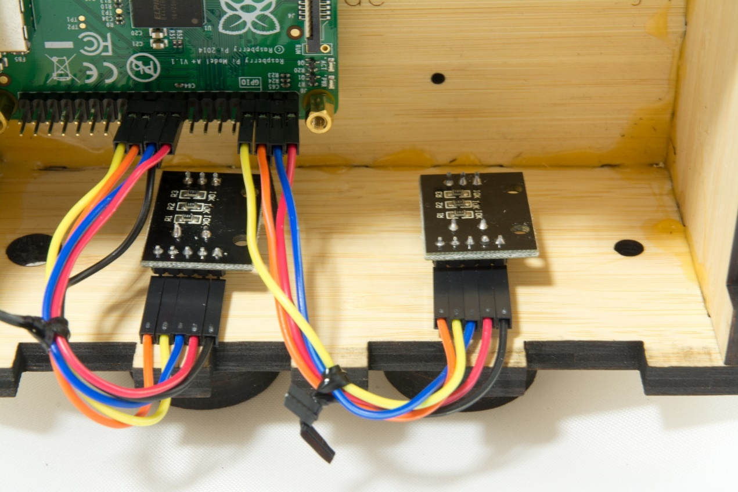

## If the wood knobs are loose on the metal shafts

Just glue the wood knobs to the metal shafts. But only if it is really necessary. Once the knobs & shafts are glued, it’s harder to dissemble the box to fix any problems.

## Tape instructions

Print this page and tape the instructions in the box below to the bottom of your new DQMusicBox:

|  |
| --- |
| **To create personalized music**  **Organize the music on your computer**  One folder per album. Use MP3 files, must have .mp3 file extension. Or iTunes files (.m4a). Or FLAC files (.flac). Optionally, use folder names prefixes to specify the play order e.g. A_, B_  **Copy the music to the USB thumb drive**   1. https://images-na.ssl-images-amazon.com/images/I/71cTRglrgcL._SL1500_.jpgUnplug your DQMusicBox. 2. Remove the USB thumb drive and place in your computer. 3. Copy music files from your computer to the USB thumb drive. 4. Put the USB thumb drive back in the DQMusicBox. 5. Plug in your DQMusicBox. |

## Congratulations

Congratulations! You should have a fully functional DQMusicBox.

# Appendix 1: Write protect the SD card

## About SD card write protection TMP_WRITE_PROTECT

**This step is optional.** It will increase the durability of the system. If you or your friend already work with Raspberry Pis, you may find this fun. If you don’t then you might find this frustrating and it’s perfectly OK to skip this optional step.

About TMP_WRITE_PROTECT:

* Raspbian and DietPi, don’t generally like to be rudely shut down i.e. having the power plug pulled.
* Rude power downs can interrupt writes to the micro SD card and potentially corrupt the OS.
* But we have a special case here, because DQMusicBox does not need to be online and does not need to be updated. In other words, it is safe to write protect the micro SD card.
* The SD card standard has a rarely used feature known as TMP_WRITE_PROTECT (which is a useful google search term) i.e. temporary write protection.
* When in this mode, the SD accepts write accepts write requests, but any such writes are made to temporary storage and are deliberately lost upon reboot or power loss.
* In other words, if you pull the plug on a DQMusixBox you are effectively doing a factory reset. Music stored on the USB thumb drive is unaffected.
* To enable this, set the TMP_WRITE_PROTECT bit in the Card Specific Data on micro-SD card (more on this below).
* Here is the SD Association’s official description of TMP_WRITE_PROTECT from the [SD Specifications Part 1 Physical Layer Simplified Specification Version 6.00](https://www.sdcard.org/downloads/pls/pdf/index.php?p=Part1_Physical_Layer_Simplified_Specification_Ver6.00.jpg&f=Part1_Physical_Layer_Simplified_Specification_Ver6.00.pdf&e=EN_SS1):  
  *Temporarily protects the entire card content from being overwritten or erased (all write and erase commands for this card are temporarily disabled). This bit can be set and reset. The default value is 0, i.e. not write protected.*
* For the curious, here are some of the other fields in the Card Specific Data, chart taken from the same document linked just above:  
  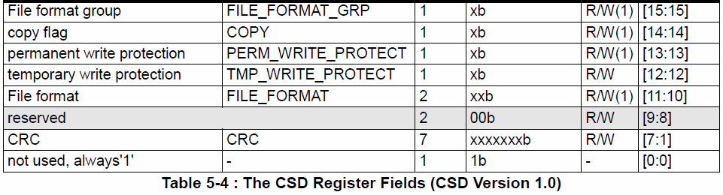
* References:
  + [SD Card Write Protection](http://www.bertold.org/sdtool/)
  + [Build the SD Locker and Make Your SD Cards More Secure](Build%20the%20SD%20Locker%20and%20Make%20Your%20SD%20Cards%20More%20Secure)

## Option 1: Build the SD locker project

There are several ways to implement TMP_WRITE_PROTECT. I was originally inspired by the [SD locker project on Hackaday](http://hackaday.com/2013/11/12/keep-your-sd-cards-data-safe-with-the-sd-locker/) and by its [successor](https://www.seanet.com/~karllunt/sdlocker2.html). Both of which look like fun. But I ended up using Option 2 below as it is more consistent with Raspberry Pi work.

## Option 2: Use a Raspberry Pi 3

This is the option that I used. In brief, the write protection process is:

1. Write the DQMusicBox image to a micro-SD card, as per the instructions above.
2. Boot a Raspberry Pi 3 from a USB thumb drive.
3. Once booted, insert a micro-SD card and issue the following command:  
   sudo ./sdtool/static/arm-sdtool /dev/mmcblk0 lock

This is my setup for doing so:

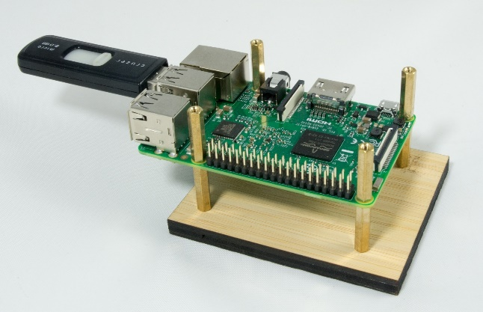

The slightly tricky bit is to get the Raspberry Pi 3 to boot from USB. See below for the process that I used to create to create the setup above. You will only have to do this once.

1. You’ll need:
   1. **A Raspberry Pi 3**. I keep a Pi 3 just for this purpose i.e. I don’t use this Pi 3 inside a DQMusicBox.
   2. **A good USB thumb drive.** I keep a thumb drive just for this purpose. Apparently this won’t work with some low performance USB thumb drives, although it worked with my old 2GB thumb drive (pictured above). I now use a [SanDisk Extreme 32GB thumb drive](https://www.amazon.com/gp/product/B00KT7DXIU/ref=oh_aui_detailpage_o00_s00?ie=UTF8&psc=1).
   3. **A micro-SD card.** You will only need for 30 minutes to complete the steps below, then you can use the card for other purposes.
2. Download [DietPi](http://dietpi.com/).
3. Write the DietPi image to the micro-SD card (using Etcher or Win32diskimager).
4. Write the same DietPi image to the USB thumb drive.
5. Attach Ethernet to your Raspberry Pi 3.
6. Insert the micro-SD card.
7. Start the DietPi installation process i.e.:
   1. Boot the Pi 3 from the micro-SD card
   2. Connect to the Pi 3 over the network with Putty or something similar, login with username=root password=dietpi
8. After a while, you will get to this screen, choose DietPi-Config  
   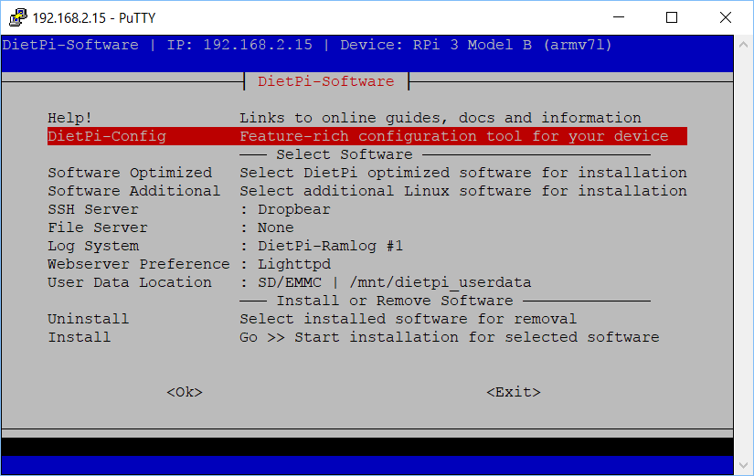
9. Choose Advanced Options:  
   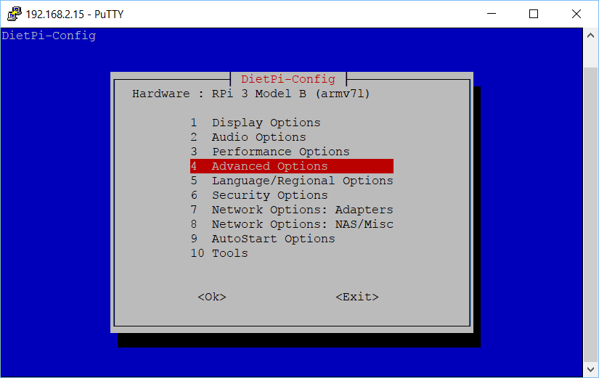
10. Choose USB boot support and choose to **enable** it:  
    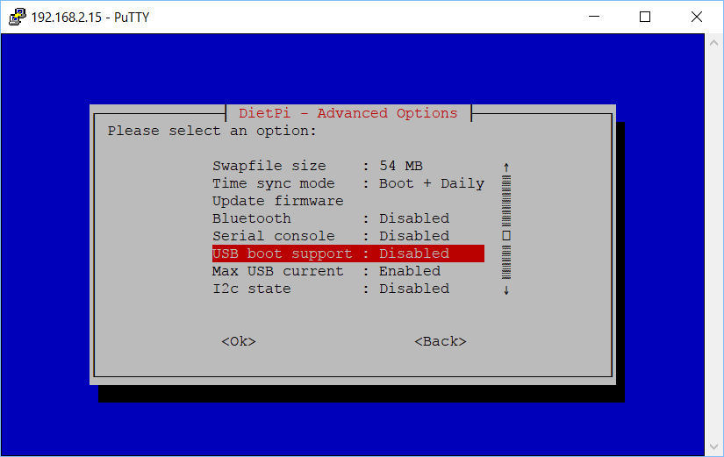
11. Choose OK (read the full message first):  
    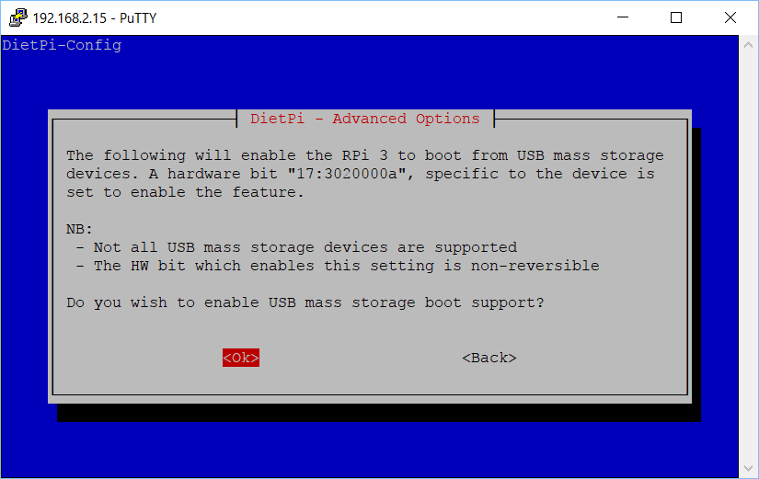
12. Choose Yes to reboot:  
    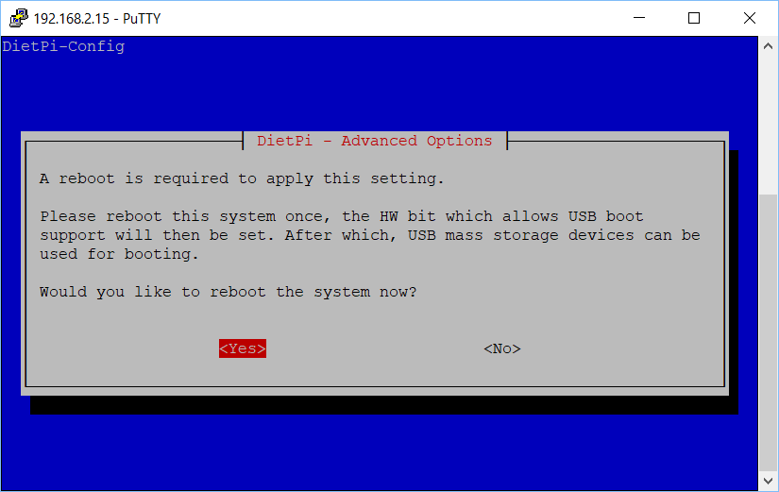
13. After rebooting, choose Install:  
    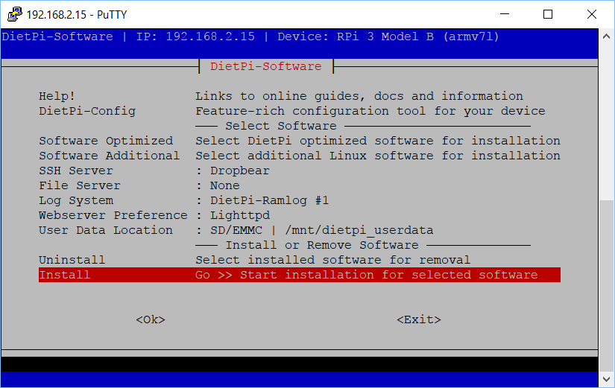
14. Let the installation run and finish.  
    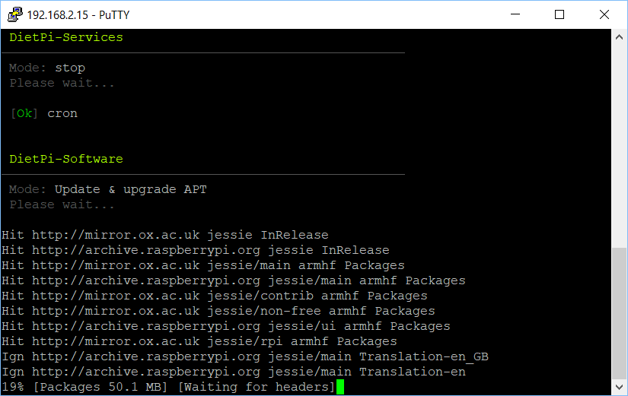
15. Once the installation is complete, switch to a USB setup:
    1. Unplug the Pi.
    2. Remove the micro-SD Card.
    3. Insert the USB thumb drive.
    4. Plug the Pi back in and boot.
16. Install DietPi on the USB thumb drive. Start by letting DietPi update itself:  
    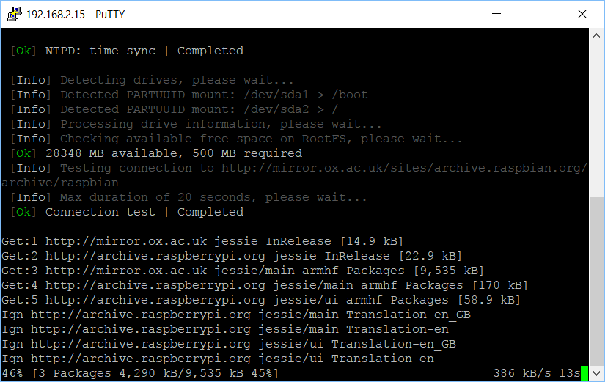
17. When prompted, restart your Pi:  
    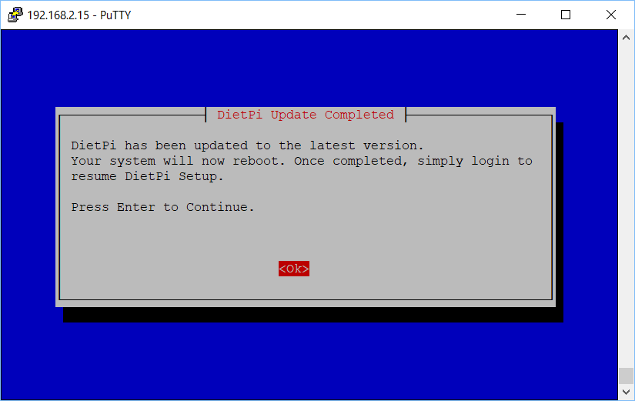
18. Install:  
    
19. Let DietPi do more updating:  
    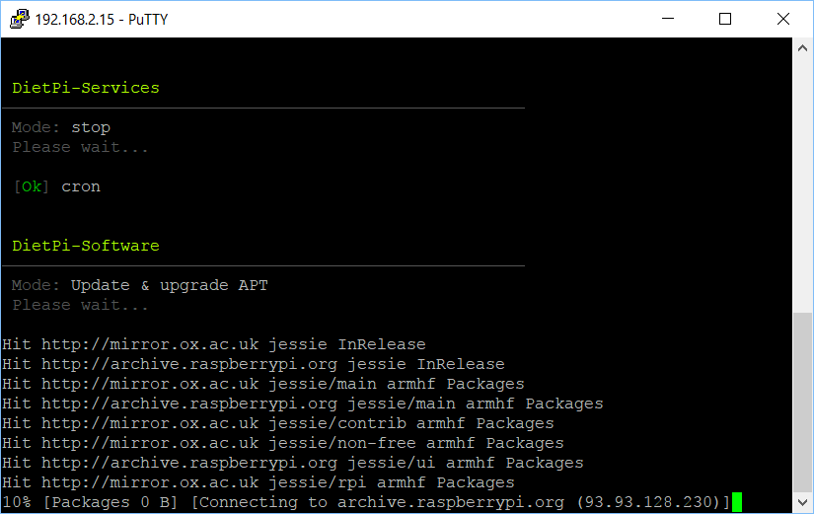
20. DietPi will reboot to complete the installation, then you’ll get a normal command prompt:  
    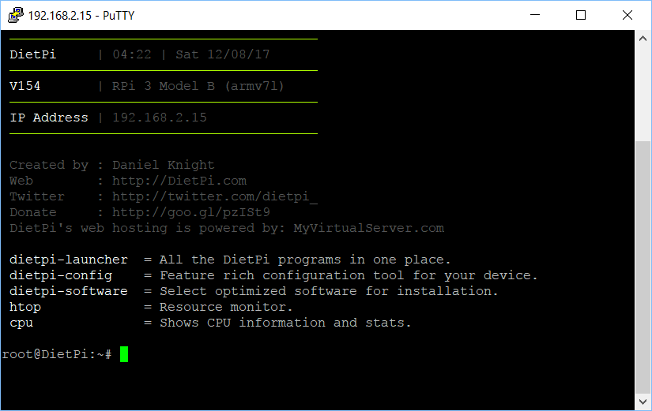
21. Install git with   
    sudo apt-get install git  
    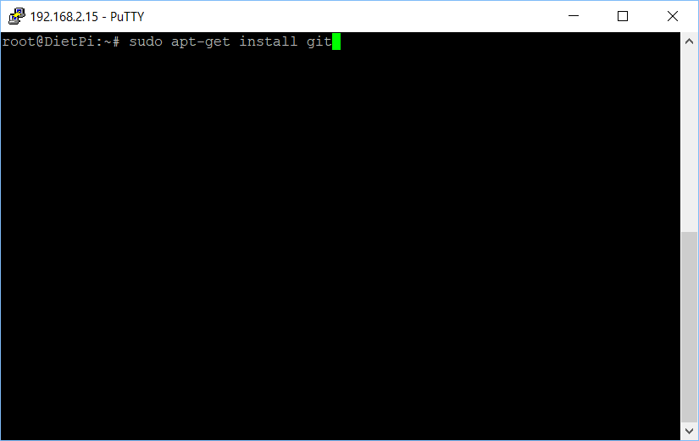
22. Get the write protection tool [sdtool](https://github.com/BertoldVdb/sdtool/blob/master/static/arm-sdtool) with   
    git clone https://github.com/BertoldVdb/sdtool  
    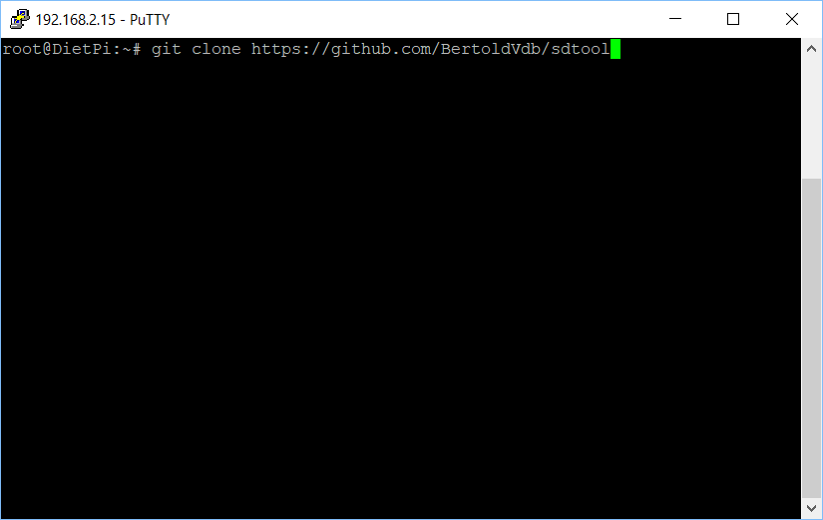
23. Put an micro-SD card in the slot, practice enabling TMP_WRITE_PROTECT:  
    sudo ./sdtool/static/arm-sdtool /dev/mmcblk0 lock  
    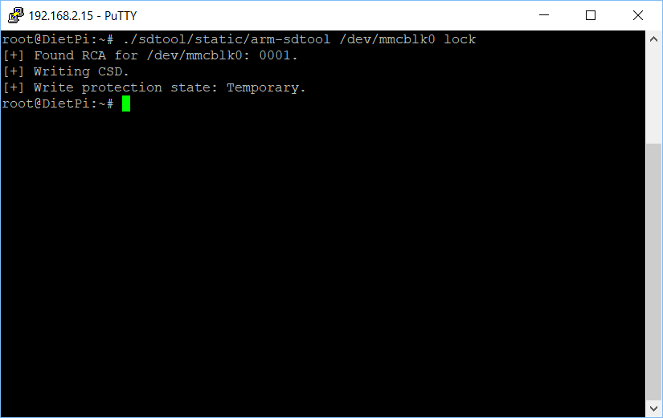
24. Now practice reversing the above:  
    sudo ./sdtool/static/arm-sdtool /dev/mmcblk0 unlock  
    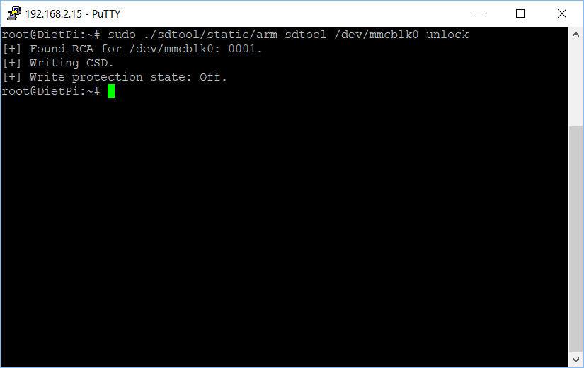
25. You are done!

# Appendix 2: Change log

|  |  |
| --- | --- |
| v1, November 2015 | Original release |
| v2, September 2016 | * Changed music storage from a micro-SD memory card to a conventional USB memory stick. * Changed the base Operating System from full Raspbian to [DietPi](http://dietpi.com/) – much smaller, so faster to boot, and less to go wrong. |
| v3, January 2017 | * Changed from USB audio to Pi built-in audio, including a firmware update for excellent audio quality. |
| v4, May 2017 | * Switched to bamboo for durability and use of standoffs. * Switched to Pi A+ to lower cost. * Made USB thumb drive externally accessible, to make it easier for the caregiver to organize music. |
| v4.01, 25 June 2017 | * Minor edits. |
| v4.01_1, 20 July 2017 | * Minor edits. |
| v4.01_2, 11 August 2017 | * Added links for ordering parts in the UK. * Added detailed instructions for write protecting a micro-SD card. |
| v4.01_3, 12 August 2017 | * Minor edits |
| v4.01_4, 12 August 2017 | * Minor edits |
| v4.01_5, 14 October 2017 | * Edited text and updated photographs to reflect the change from an HDD-style LED to a KY-016 LED module. |
| v4.01_6, 26 February 2018 | * Updated the links for purchasing the parts. No changes to the parts themselves, just the links. * Minor change to the instructions, noting how the build can be accomplished in one sitting, if desired. |
| v4.1, 7 April 2018 | * Reflects that the software has been updated to support the new Raspberry Pi 3 B+. No new software features. |
| v4.1_1, 23 April 2018 | * Updated to reflect the new bamboo case design. |